Angry Jungle Birds

Design Document

#### Víctor Hugo Montiel Gómez

Contents

Game Overview 3

Summary 3

Gameplay 3

Mindset 3

Highlights 3

System Design 3

Input 3

Output 3

Behaviors 3

Game Screen Mockups 4

Visual Design 7

Color Palette 7

Stylistic Attributes / Elements 7

Music / Sound Design 7

Sound Palette / Instrumentation 7

# Game Overview

## Summary

A treasure hunter is sent to the jungle to retrieve its many rewards. The jungle birds will try their best to stop him.

## Gameplay

The player will traverse the jungle and other scenarios to collect coins, enemies like birds and tornadoes will damage him. Coins and treasures will await him.

## Mindset

The player will have to be mechanically skilled to be able to cross the dungeons without dying. Many repetitions will be needed in order to accomplish this. Also to get the highest score possible the player will have to take harder routes. It is a very simple mechanic but hard to achieve.

## Highlights

* The many challenges and enemies will make the player’s life a living hell
* The many possibilities of increasing your score will keep the player addicted.

# System Design

## Input

The player moves with the arrow and does an animation with space bar of attacking.

## Output

Colliding with an enemy will decrease the player HP and will make him bounce. Collecting rewards and hearts will increase the score and player’s hp respectively,

## Behaviors

* Player
  + Moves
  + Jumps
  + collects
* Enemies
  + damage
* Platforms
  + Some move
* Props
  + Hearts
  + Rewards

# Game Screen Mockups

Menu

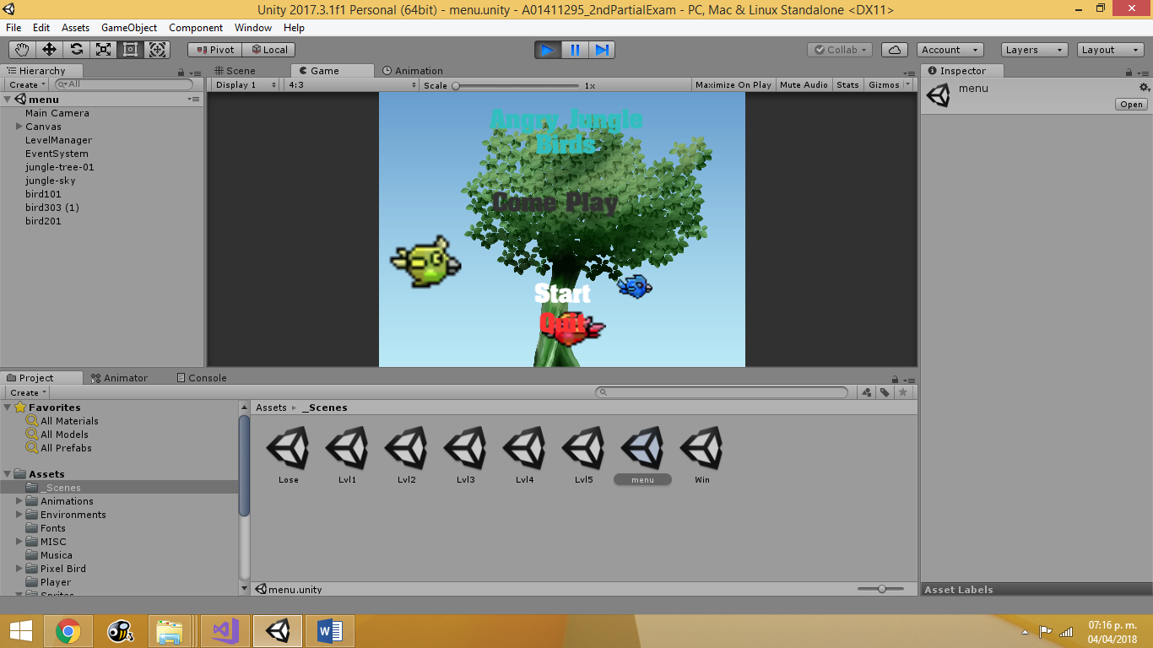

First level

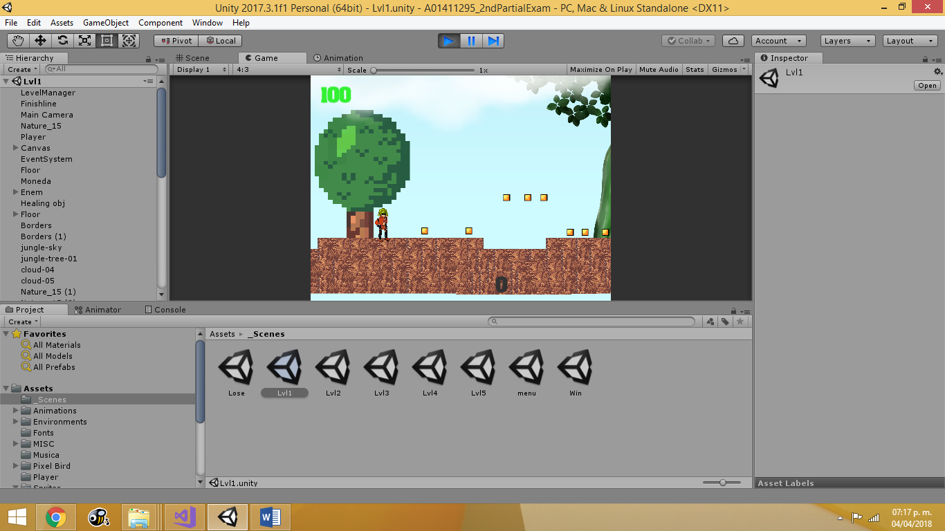

Second level

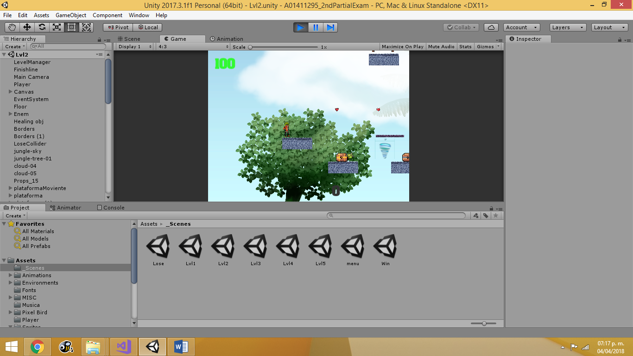

Third Level

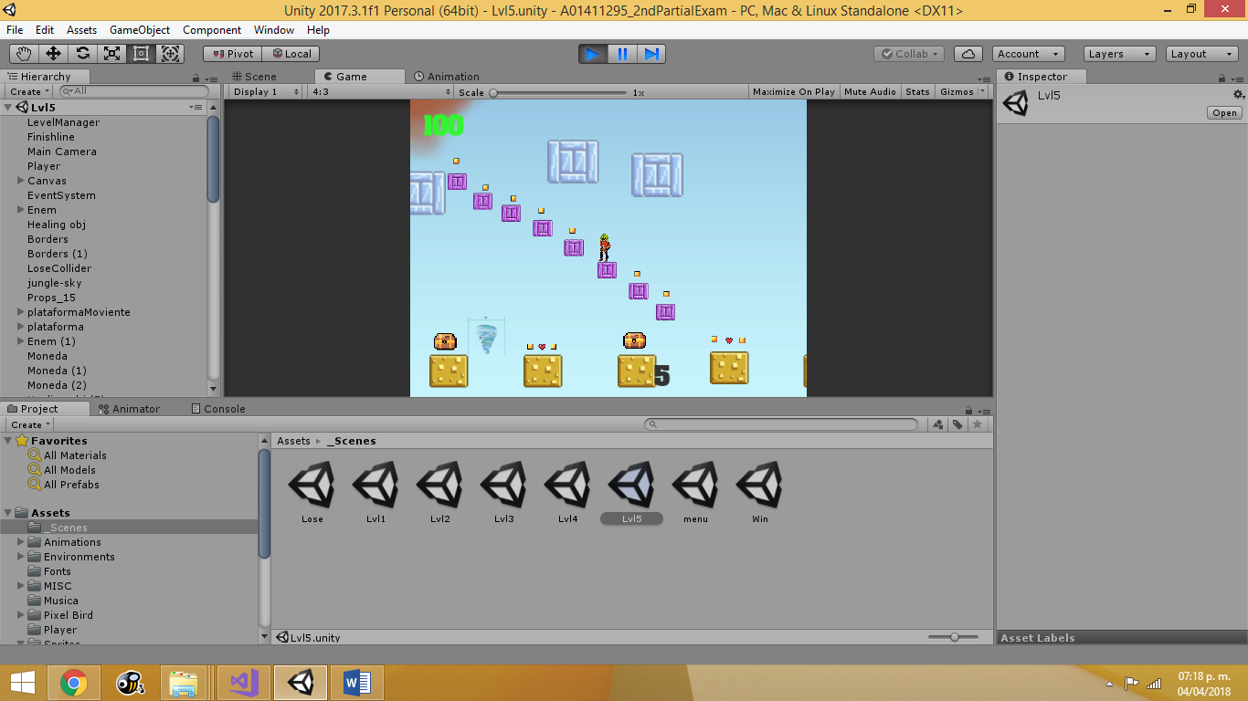

Fourth Level

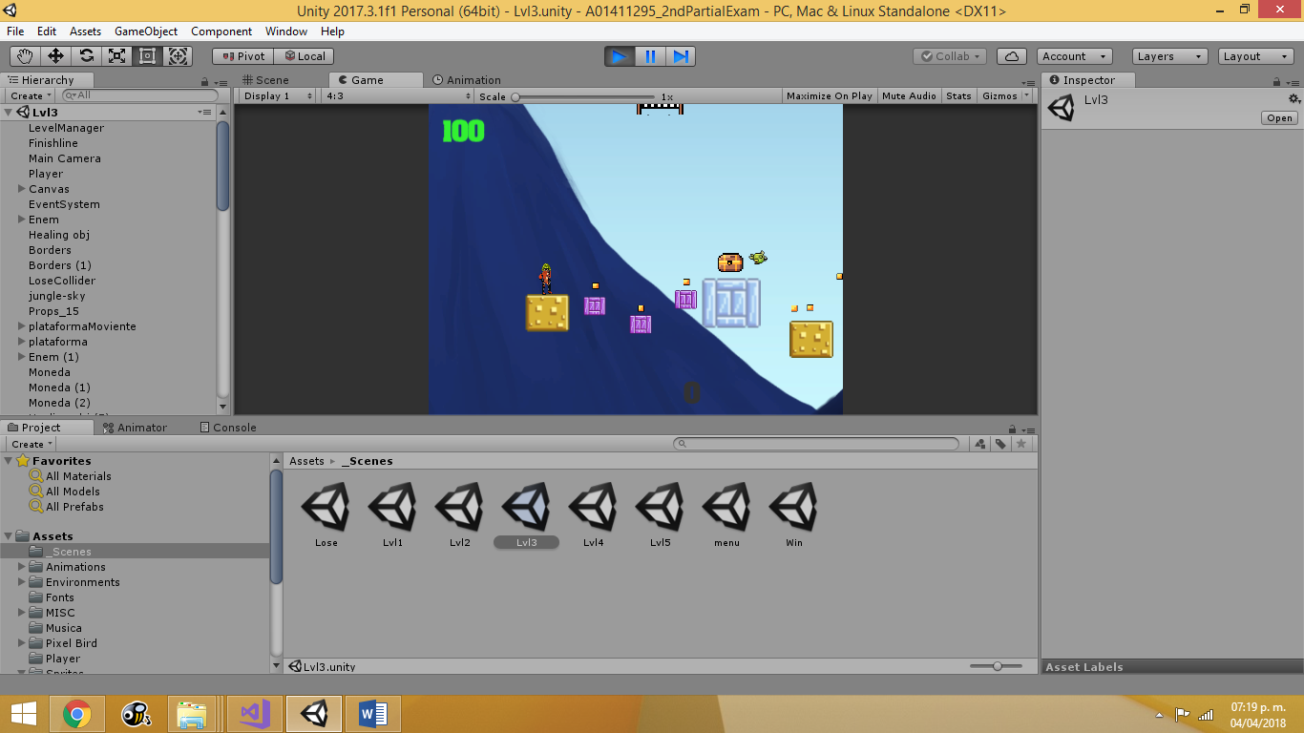

Fifth Level

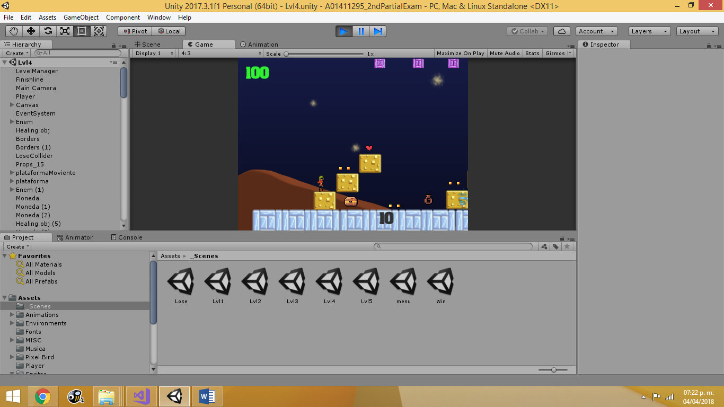

Win Screen

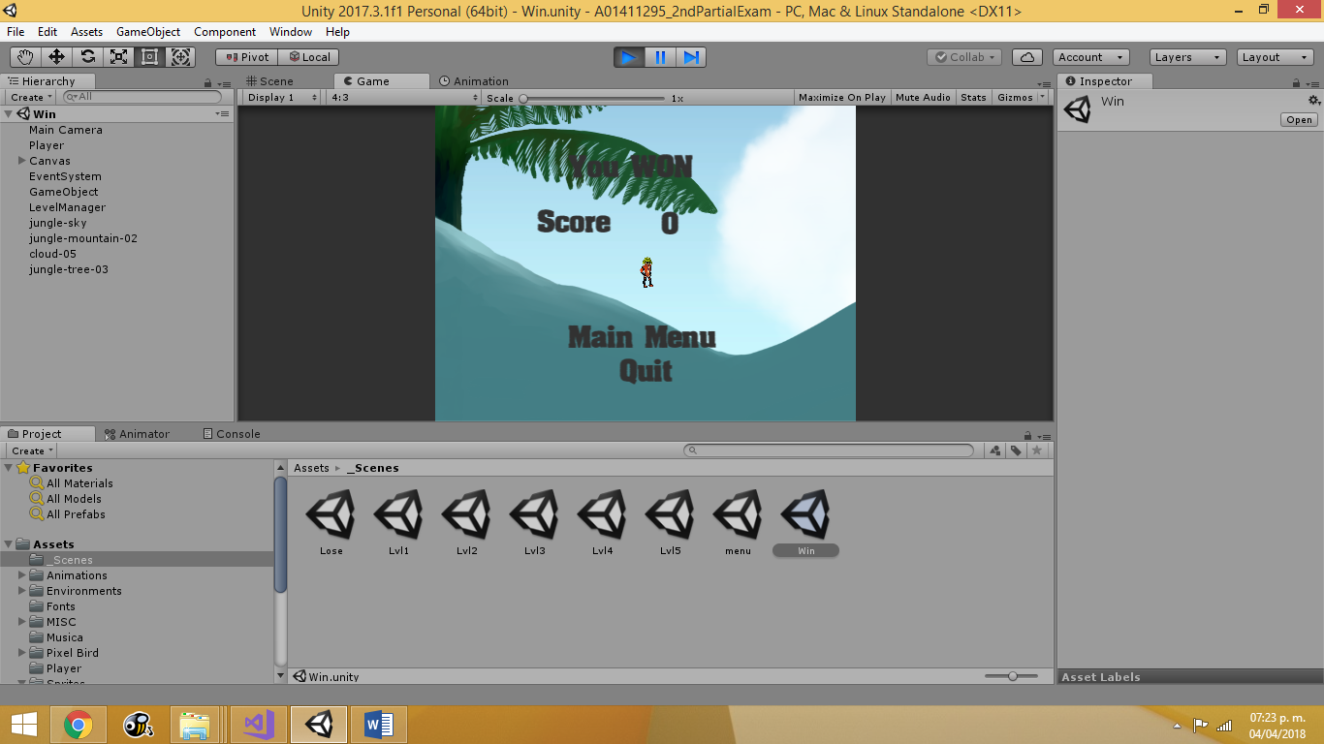

Lose Screen

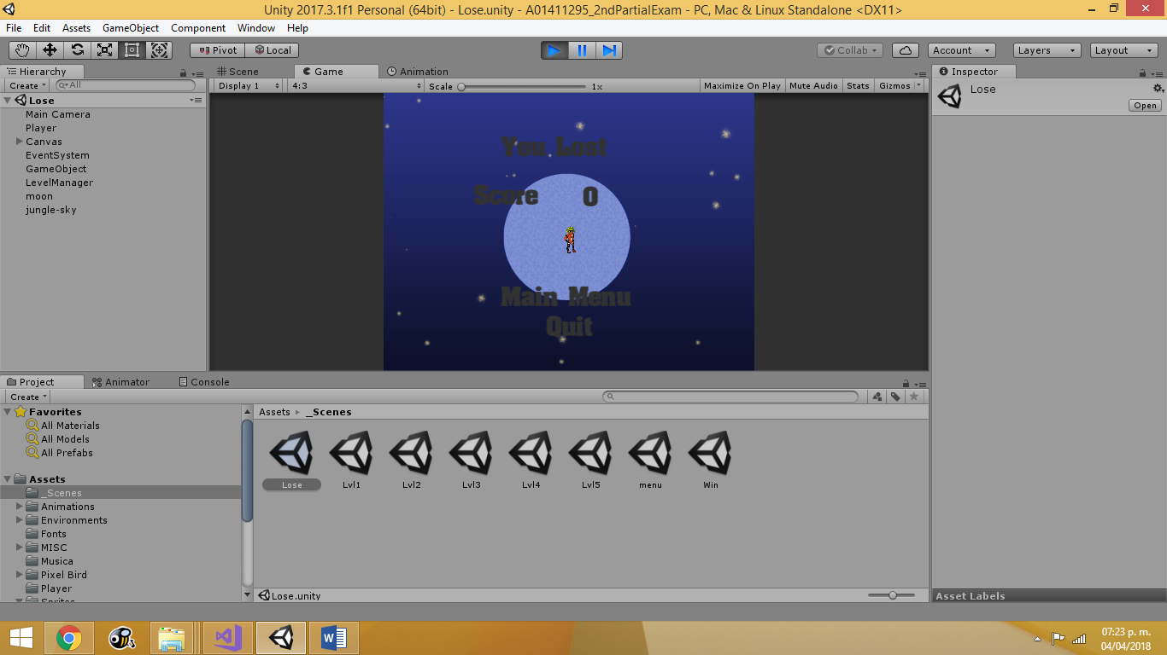

# 

# Visual Design

## Color Palette

Greens, browns and dark blues to represent the jungle in the morning, afternoon and night.

## Stylistic Attributes / Elements

The aesthetic of this game is ugly on purpose.

# Music / Sound Design

## Sound Palette / Instrumentation

The sounds are mainly birds chirping in an aggressive manner.